Newsletter December 2012

A combination of permeation grouting, waterproofing and
industrial concreting and grouting has kept us busy. With some bentoniting lined up for the new year to complete our portfolio.

Project Update

QANTAS Building, Mascot
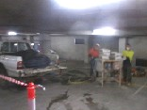
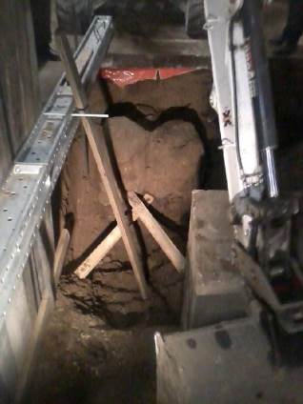
FDC are responsible for the upgrading of the QANTAS head office in Mascot which requires upgrading the column loadings and hence foundation requirements. Due to limited access GFWAust was asked to trial permeation grouting to provide improved founding beneath one of the columns. The trial proved co-joined columns of grouted sand each with a diameter of 700mm.

Dryflex
GFWAust gas continued to provide waterproofing solutions with Dryflex as a repair system for leaking basements.

Kogan North Gas Compressors
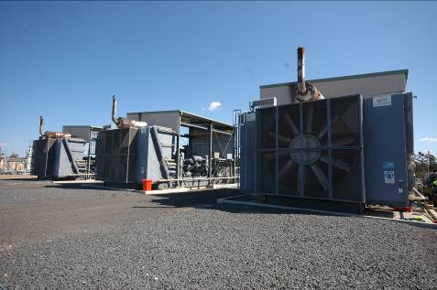
After successfully grouting and concreting the pedestal of one compressor last year at Kogan North. GFWAust were invited back by APA to do the other two
The APA gas compressors at Kogan have been experiencing vibration problems which were affecting their stability. An assessment by vibration specialists Vipac determined that filling filling the pedestal with fiber reinforced concrete would provide stability to the structure.
GFWAust provided expertise in determining the most appropriate materials and mix details and were appointed to carry out the grouting and concreting works. The works included grouting a seal with a high performance grout around the skid and then filling with a steel fibre reinforced concrete and finally pressure grouting to ensure a complete fill of the pedestal.

Scotts College
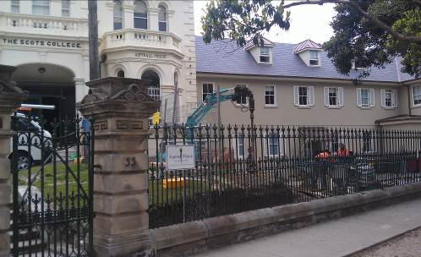
Following some movement of the front facade of Aspinall House, GFWAust were asked to underpin the building using permeation grouting in the Aeolian sand. GFWAust mobilized immediately to treat the problem. The process was carried out with ultrafine grout both outside and inside the front wall including some low headroom work in about 1m but still achieving a depth of 2.5m grout injection.
David Lees and Associates Pty Ltd

KBR and Sydney Water
David is continuing with work for KBR to review the condition and procedures for sewer tunnels across Sydney. During this period he has completed the traverse of the Seaforth tunnels with a night traverse at the Spit Bridge

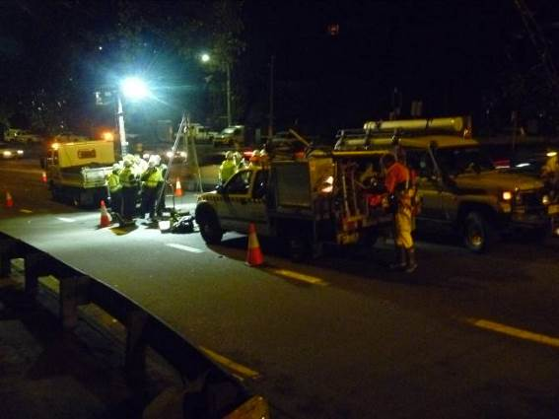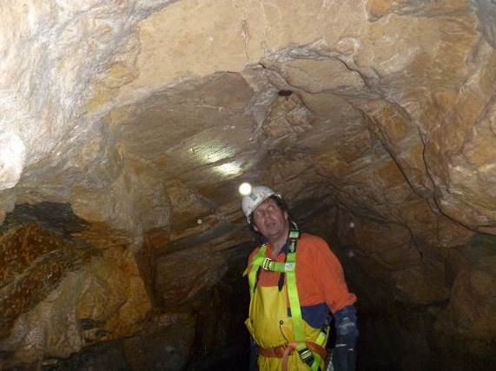

And traverse of the Newport Tunnel..

David has also carried out a design review for KBR on the South Kedron Brook sewer

Other Consultancy Work
David has assisted one of the tenderers for the NW Rail Link in Sydney with a review of their blasting proposals.

Expert witness
David has continued his expert witness work on two current cases.

Publications and presentations

David has been working on the National Tunnelling Code of Practice with Safe Work Australia

David gave a presentation to Leighton contractors in August on grouting in tunnels and in September gave a presentation at the ATS Tunnel Course on the Control of Groundwater

David’s second novel The Power of Water is now available through Equilibrium Books

http://www.equilibriumbooks.com/powerofwater.htm

His first Novel Terror Under Sydney is still available through Amazon Books

http://www.amazon.com/Terror-under-Sydney-David-Lees/dp/141969913X

He is currently working on a story on the life and times of George Stevenson – the father of modern railways.

