Newsletter December 2015
Completing his appointment in Nepal in May, David returned to Australia and GFWAust carried out some permeation grouting work in Sydney. Then David left for Sri Lanka to grout high pressure water in a TBM tunnel for a hydro-project and GFWAust teamed up with Mailnmark Mining and Civil to carry out permeation grouting works in Sydney as well as assisting with pressure grouting on the True Blue Mine Shaft rehabilitation in West Wyalong
Project Update

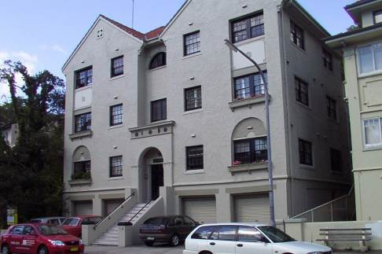
Manning Road, Double Bay

The owner of 13 Manning Road wanted to excavate an extension beneath his property at the back of the garage. GFWAust provided stabilization to the sand beneath the load bearing walls to enable excavation and underpinning.

34a Francis Street, Bondi
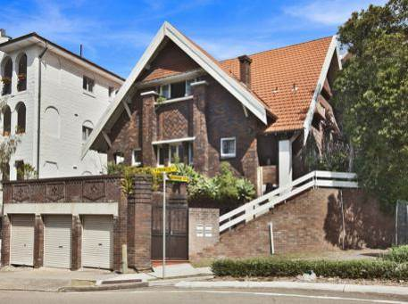
The property at 34a Francis street is located on a elevated site. There were concerns over stability of the retaining wall on the eastern boundary to the adjacent lower site and movement of the front wall. GFWaust had proposed a permeation grouting solution to strengthen the eastern and northern sides and also to enable a retaining wall to be constructed in the back garden on the southern side. GFWAust then provided assistance to Mainmark Mining and Civil to carry out the works.

True Blue Mine Shaft, West Wyalong
After the previous contractor had failed to complete the works The Department of Derelict Mines appointed Mainmark Mining and Civil to complete the works. The original proposal was to place a sacrificial inflatable packer at a depth of 60m to form a plug to allow a concrete fill to stabilize the top of the shaft. Mainmark’s unique solution proposed the use of a foaming polyurethane grout to create the plug. GFWAust then assisted Mainnmark in carrying out pressure grouting around the concrete plug in the collar that had been installed by the previous contractor. We understand that plugging and filling of the shaft is still on going on this most challenging of projects, let’s hope they can complete by Christmas.

David Lees & Associates

Melamchi Water Supply Project
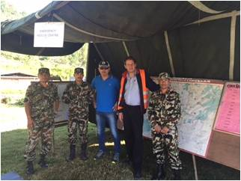
The Melamchi Water Supply Project is a 26km tunnel traversing the lower Himalayas bringing water to Kathmandu. David has been providing technical and contractual project management services for the client since July 2014. On April 25th 2015 a devastating earthquake hit the country, a second one occurred on May 12th and in between and after there have been many after shocks. The area in which the project lies Sindhupalchowk is the worst hit area and the community has suffered tremendously. After the earthquake on 25th April David assisted the emergency response teams, coordinating road clearance with the local army major. Over 90% of the houses in the area were destroyed with over 2,000 dead, The country's death toll was over 10,000. David’s contract concluded at the end of May 2015 and he returned home to Australia.
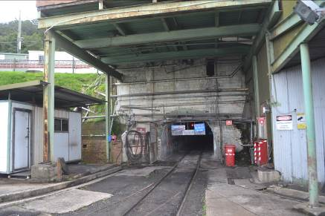
Russell Vale Colliery
David assisted Mainmark Civil and Mining in determining a typical design for plugging the portals of Russell Vale Colliery. The colliery is one of the oldest in Australia and the workings extend beneath the catchment of the Cataract Dam. The requirement was to determine the most feasible way to plug these portals in case of rupturing the reservoir above

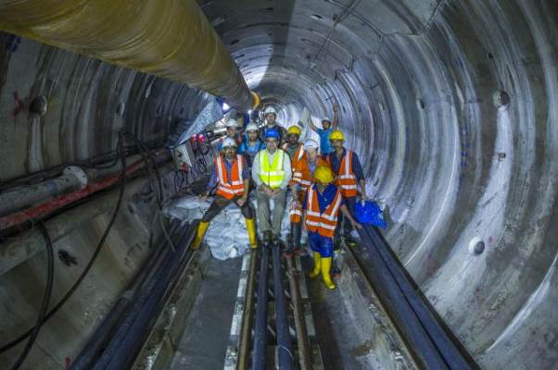
Uma Oya Multipurpose project, Sri Lanka
In August David joined Amberg Engineering in Sri Lanka on the Uma Oya project as their Chief Site Supervisor. Here he is responsible for the construction of a 15km headrace tunnel and a 3.7km link tunnel between the two dams. The TBM in the 15km headrace tunnel has been stopped since May 2015 to carry out grouting works but will recommence in Deecember 2015. The intake and the link tunnel are being excavated by drill and blast with a second TBM planned for the intake section of the headrace tunnel.

Publications and presentations

David presented a paper on the Melamchi Water Supply Project at the Seventh Nepal Geological Congress (NGC-VII) held in Kathmandu in April 2015.

Following the successfull pulication of The History Of Australian Tunnelling for the ATS a few years ago, David is currently working on The History of New Zealand Tunnelling which should be published next year

