Newsletter December 2014
10th Anniversary – 2004 to 2014
Busy start to the new financial year, then David decided to go to Nepal to supervise the construction of a 26km through the Himalayas.

Project Update
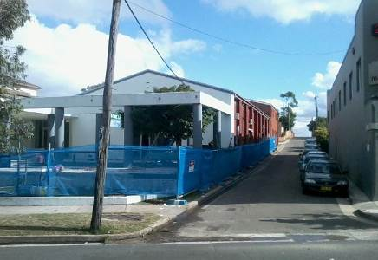

Maroubra Synagogue
Belmadar were appointed to install blast walls along the sides of the Maroubra Synagogue. Belmadar asked GFWAust to further provide additional sand stabilisation as well as stabilization of contaminated soil using permeation grouting with microfine cement.

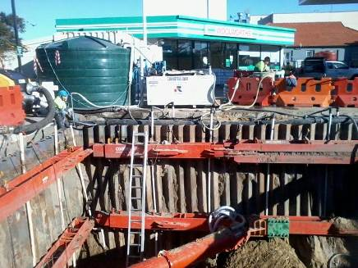
Caltex, Roseberry
Unable to provide a dry basement due to leaking sheetpiles and a high water table, GFWAust provided expertise to assist in sealing the leaking retaining wall and provide a dry base to the excavation.

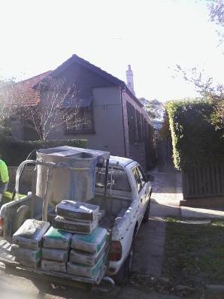

Balfour Road
GFWAust provided underpining along for a house that had been subject to some settlement and required an extension above with increased loading on the outside walls. Permeation grouting was carried out with nominal disturbance to the property or its gardens.

Rouse Hill Water Recycling Plant
GFWAust were asked by PET Technologies to assist with grouting an important spigot in one of the modified digesters. GFWAust proposed an antishrink, antiblleed early strength grout to carry out the work.
David Lees & Associates 15th Anniversary – 1999 to 2014

Melamchi Water Supply Project
The Melamchi Water Supply Project is a 26km tunnel traversing the lower Himalayas bringing water to Kathmandu. David has been providing technical and contractual project management services for the client. The tunnel is drill and blast through gneiss and quartzite with some good areas of hard rock and some very soft areas of poor ground. The contract is being constructed by an Italian contractor with a Scandinavian Engineer and designer. The headworks includes several coffer dams a diversion tunnel and some desilting basins.
Initially contracted for 10 weeks David returned for an extended contract to assist the Resident Project Manager, to conclude the design and to supervise the construction works.
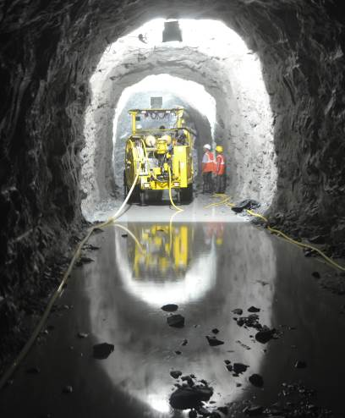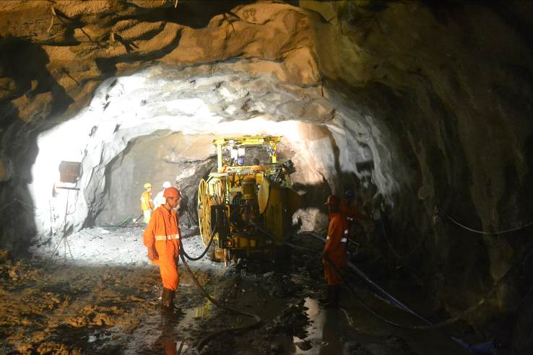
Publications and presentations
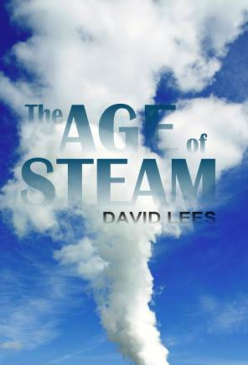
David co-authored a paper with Daryl Gilchrist Sydney Water’s Principle Engineering Geologist. for the 15th Australian Tunnelling Conference held in Sydney in September. The paper “The development of a procedure for the inspection of unlined rock service tunnels” is a culmination of siz years of carrying out inspectons of sewer tunnels for Sydney Water.

David’s has published his third novel The Age of Steam based on the life and times of George Stevenson – the father of modern railways and is available through Equilibrium Books.

David’s second novel The Power of Water is now available through Equilibrium Books
http://www.equilibriumbooks.com/powerofwater.htm

His first Novel Terror Under Sydney is also still available through Amazon Books
http://www.amazon.com/Terror-under-Sydney-David-Lees/dp/141969913X

David’s is currently working on a story on the construction of tunnels under the Thames, from the early attempts by Dodds and Trevithick to the final success by Brunel in 1843

Following the successfull pulication of The History Of Australian Tunnelling for the ATS a few years ago, David is currently working on The History of New Zealand Tunnelling.

