Newsletter June 2013

It has been a quiet six months but we have has some interesting projects to work on, both with grouting and blasting to provide slope stabilization.

Project Update

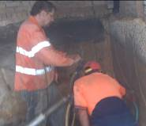
51 Bridge Road, Lane Cove
The house at 51 Bridge Road in Lane Cove had excavated an underground garage into the bedrock beneath the house. Unfortunately the excavation exposed a major bedding plane which formed a major water path for groundwater into the garage. GFWAust used a combination of cement and chemical grouts to seal the rock and eliminate the water ingress.
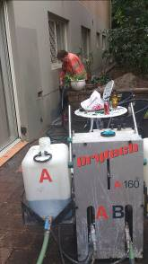

Emanuel Gardens
The Emanuel Gardens Retirement Village had seepage problems where rain runoff was seeping beneath the external wall into the living areas causing dampness to carpets. GFWAust drilled holes along the external wall to intersect the interface between the wall and the base slab and then used Dryflex injection resin under pressure to seal micro fractures within the construction to provide a waterproof seal.
Genesis Landfill
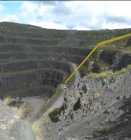
Dial A Dump Industries landfill operations at Eastern Creek are located in a 150m deep old quarry. The quarry has been excavated in a volcanic diatreme (a volcanic intrusive pipe) composed of varying amounts of sedimentary and volcanic breccia. The brecciated rocks all have different weathering characteristics some of which have formed clays whilst others remain as hard rock. GFWAust were appointed to stabilize the slope by blasting.
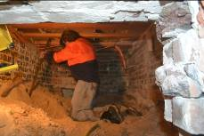
Blair Street, Bondi
Extension beneath the property at 27 Blair St included sand stabilisation. GFWAust carried out the sand stabilisation with microfine cement in a limited headroom of only 750mm, using extension pipes to provide stabilisation to a depth of 2m.
David Lees and Associates Pty Ltd
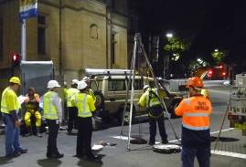
KBR and Sydney Water
David is continuing with work for KBR to review the condition and procedures for sewer tunnels across Sydney. During this period he has completed the traverse of the Elizabeth St and Market St and Prince Henry Hospital tunnels. The work in the city was carried out over night to minimize disruption to traffic.
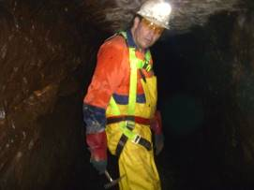
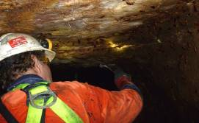
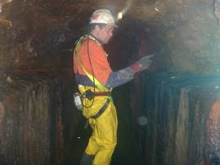
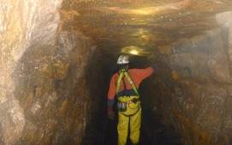
Expert witness
David has successfully completed his expert witness work on one case in the use of PCF, whilst work on a second case in tunnel grouting continues.

Publications and presentations
David has been working on the National Tunnelling Code of Practice with Safe Work Australia

David’s second novel The Power of Water is now available through Equilibrium Books
http://www.equilibriumbooks.com/powerofwater.htm
His first Novel Terror Under Sydney is still available through Amazon Books
http://www.amazon.com/Terror-under-Sydney-David-Lees/dp/141969913X

He is currently working on a story on the life and times of George Stevenson – the father of modern railways.

